**EZComm**

Learning Management System

Installation and User Manual

# About the Manual

## Purpose

The manual is supposed to offer you a comprehensive introduction of an online Learning Management System (LMS) designed and implemented by team EZComm.

Throughout this manual, you will have a basic understanding of the LMS as well as how to use the system.

## Audience

The targeted audience of this manual are the typical users of the LMS, which are students and instructors in an educational institution.

# **1. Introduction**

The communication off the class undoubtedly is as important as the class itself. To better enhance the communication between student and instructor of the class. EZComm is designed to achieve this goal. The basic product vision behind the EZComm is to make the education based communication as easy as possible.

As a web application which user can get access to and use it on web browser, EZComm doesn't just present the information related to course for student who is enrolled in different class. It also makes it easier to get the instant information for student and course management for instructors based on their needs.

With the EZComm:

Instructor who are assigned to certain courses by admin of the system can:

* See the list of all students enrolled in the classes she/he is teaching
* Create, edit, delete, and publish/unpublish course syllabus
* Create, edit, delete, and publish/unpublish course assignments
* See and grade students submissions

Student who is enrolled to all the courses during certain semester can:

* View syllabus
* View assignments
* Submit assignments and see her/his own submissions
* View her/his own grades

EZComm allows users to access their own account using email credentials ending with umd.edu from a web browser via a fairly simple interface. This document will provide instructions for using the application to achieve the functions listed above.

**2. Getting Started**

## 2.1 System Requirements and Installation

Computer with a modern web browser, for example, Google Chrome or Mozilla Firefox.

In order to install the program:

1. Install Eclipse: <https://www.eclipse.org>
2. Extract the source code that is attached.
3. Import the source code into eclipse
4. Run the application with the following commands: clean install tomcat7:run

## **2.2 Application**

### 2.2.1 Authentication

2.2.1.1 Log in

When you open the application web address. They will enter this page. Input the email and password, then click Log in to get access to system.

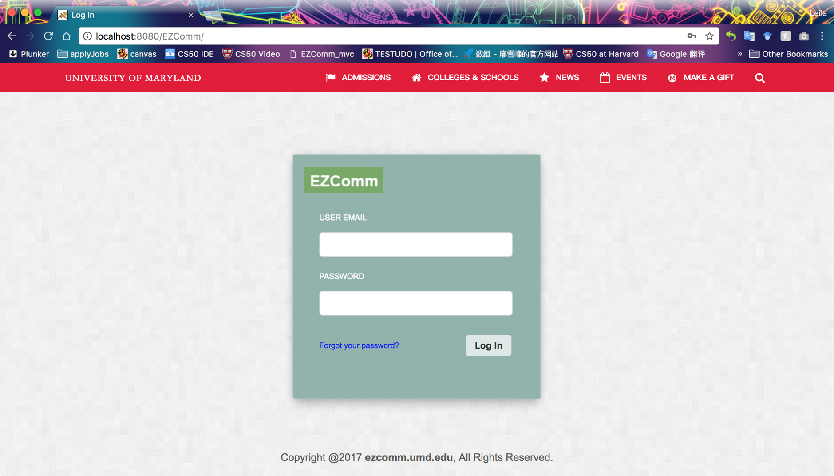

2.2.1.2 Log out

Click “logout” button on the navigation bar to exit.

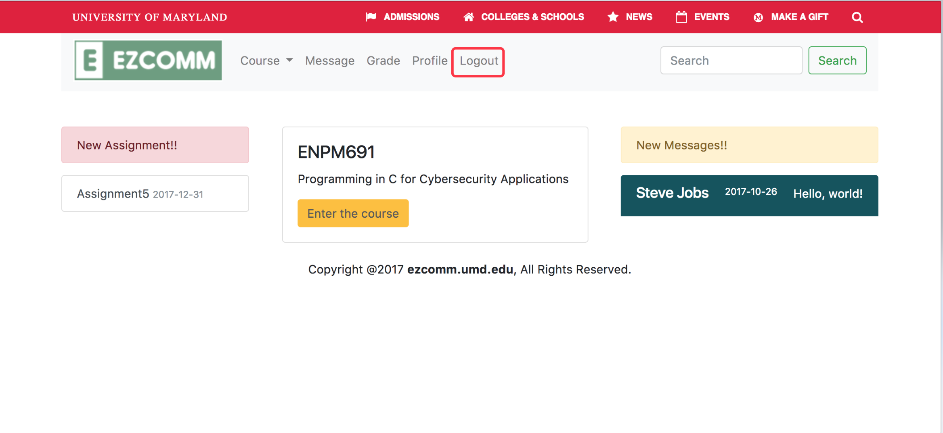

**3. Main Scenario of Use**

## 3.1 Logged in as Student

User click the course card on the homepage or the course from navigation bar to enter this page. It will guide them to the syllabus page

### 3.1.1 view syllabus

Download the syllabus from system by clicking the blue link(click here to download the current syllabus for this course), it will download and ask you to save the file to your local computer for your review;

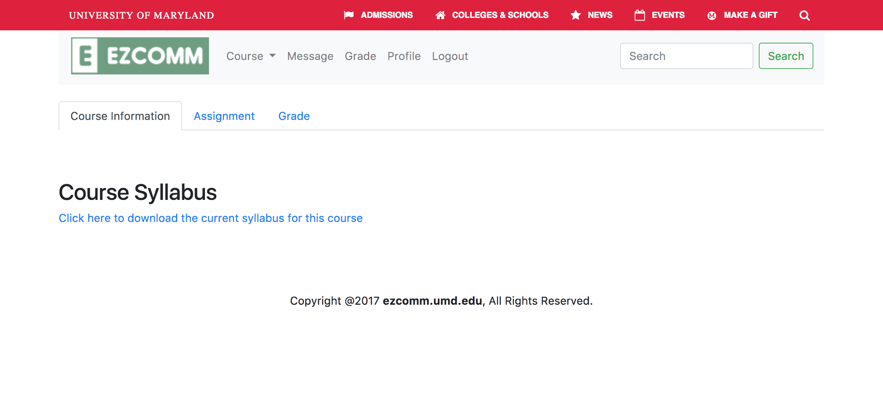

### 3.1.2 view assignment list

Click the assignment tab ,it will jump to following page which shows the assignment list for this course.There are two different categories for assignments.

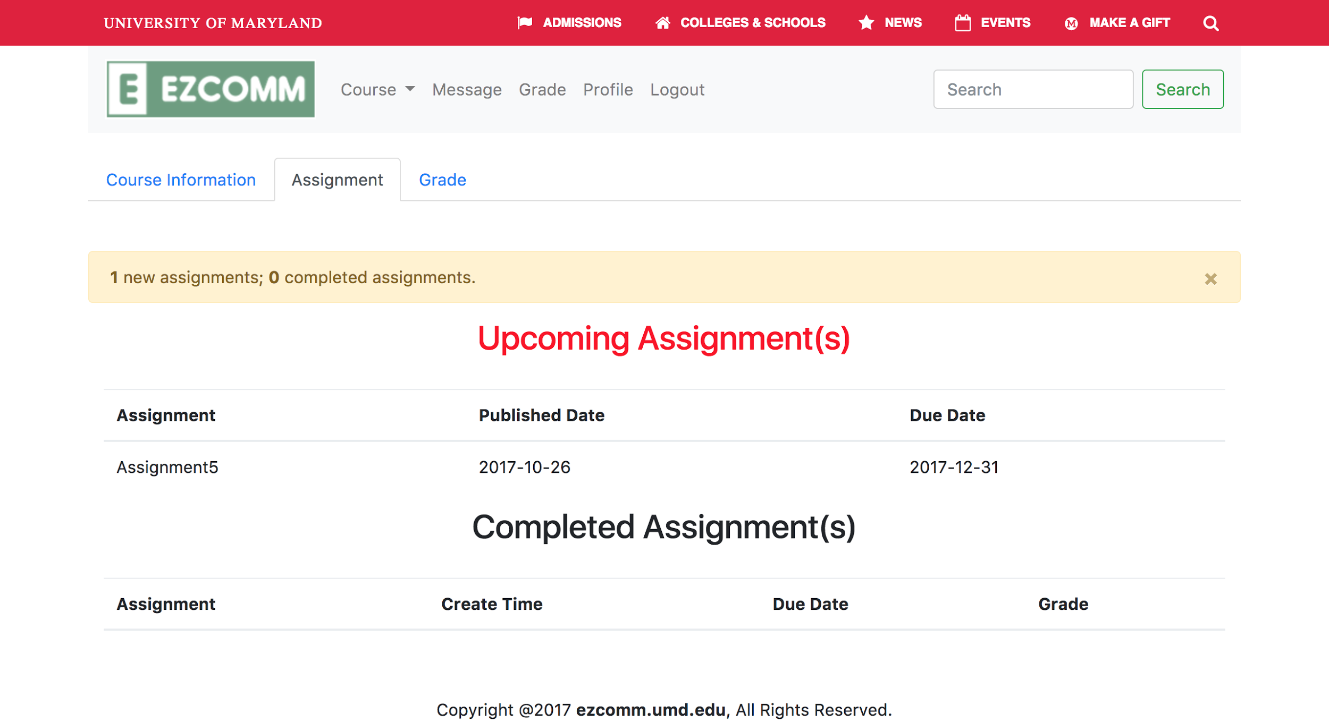

### 3.1.3 View assignment detail

### 

### 3.1.3.1 Submit file related to a specific assignment

### 

### 3.1.3.2 Review the submission and download submission file

### 

### 3.1.3.3 Review the grade and comments about this submission from professor

### 

### 3.1.3.4 View all assignments grades for certain course

### 

### 3.1.4 View all the gradebook for all courses in certain enrolled semester

By clicking the grade in the navigation bar, student will come to this page , he can review all teh grades for the courses he/she took in this semester or any other semesters based on his selection of semester.

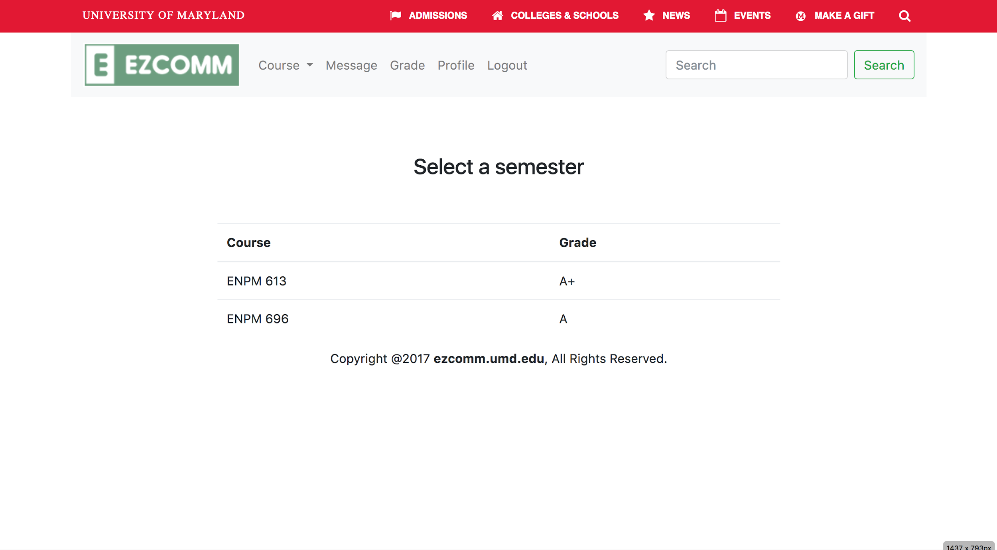

### 3.1.5 View profile and edit profile

Student can also view his own information and edit his personal information by clicking “Edit Profile”

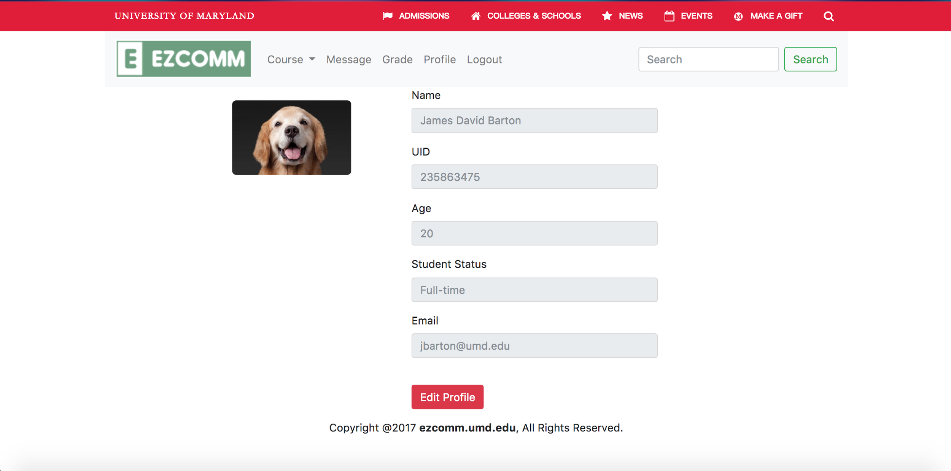

## 3.2 Logged in as Instructor

### 3.2.1 Create/edit/publish/unpublish syllabus

After instructor enters the course page. it leads his/her to this syllabus page.

Instructor will be able to see the current syllabus information.

choose to upload new Syllabus information by clicking the “choose file”button---->>> upload the syllabus document(pdf) from local computer then click” publish” button----->> update the syllabus and then publish it to student. 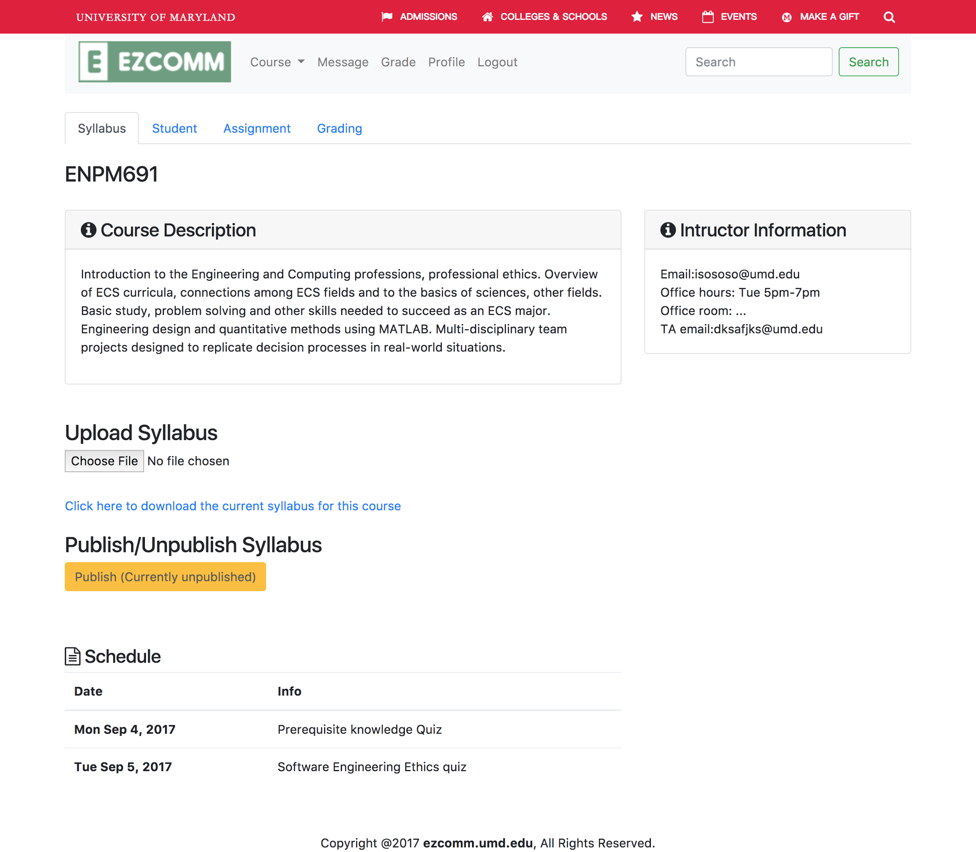

### 3.2.2 Create/edit/publish/unpublish assignment

instructor can review the current assignment :

clicking the “assignment” tab under the course >> enter the following page.

Create New Assignment: Entering the information in the input field and upload the assignment file >>> click submit button. User will be able to create new assignment and publish it.

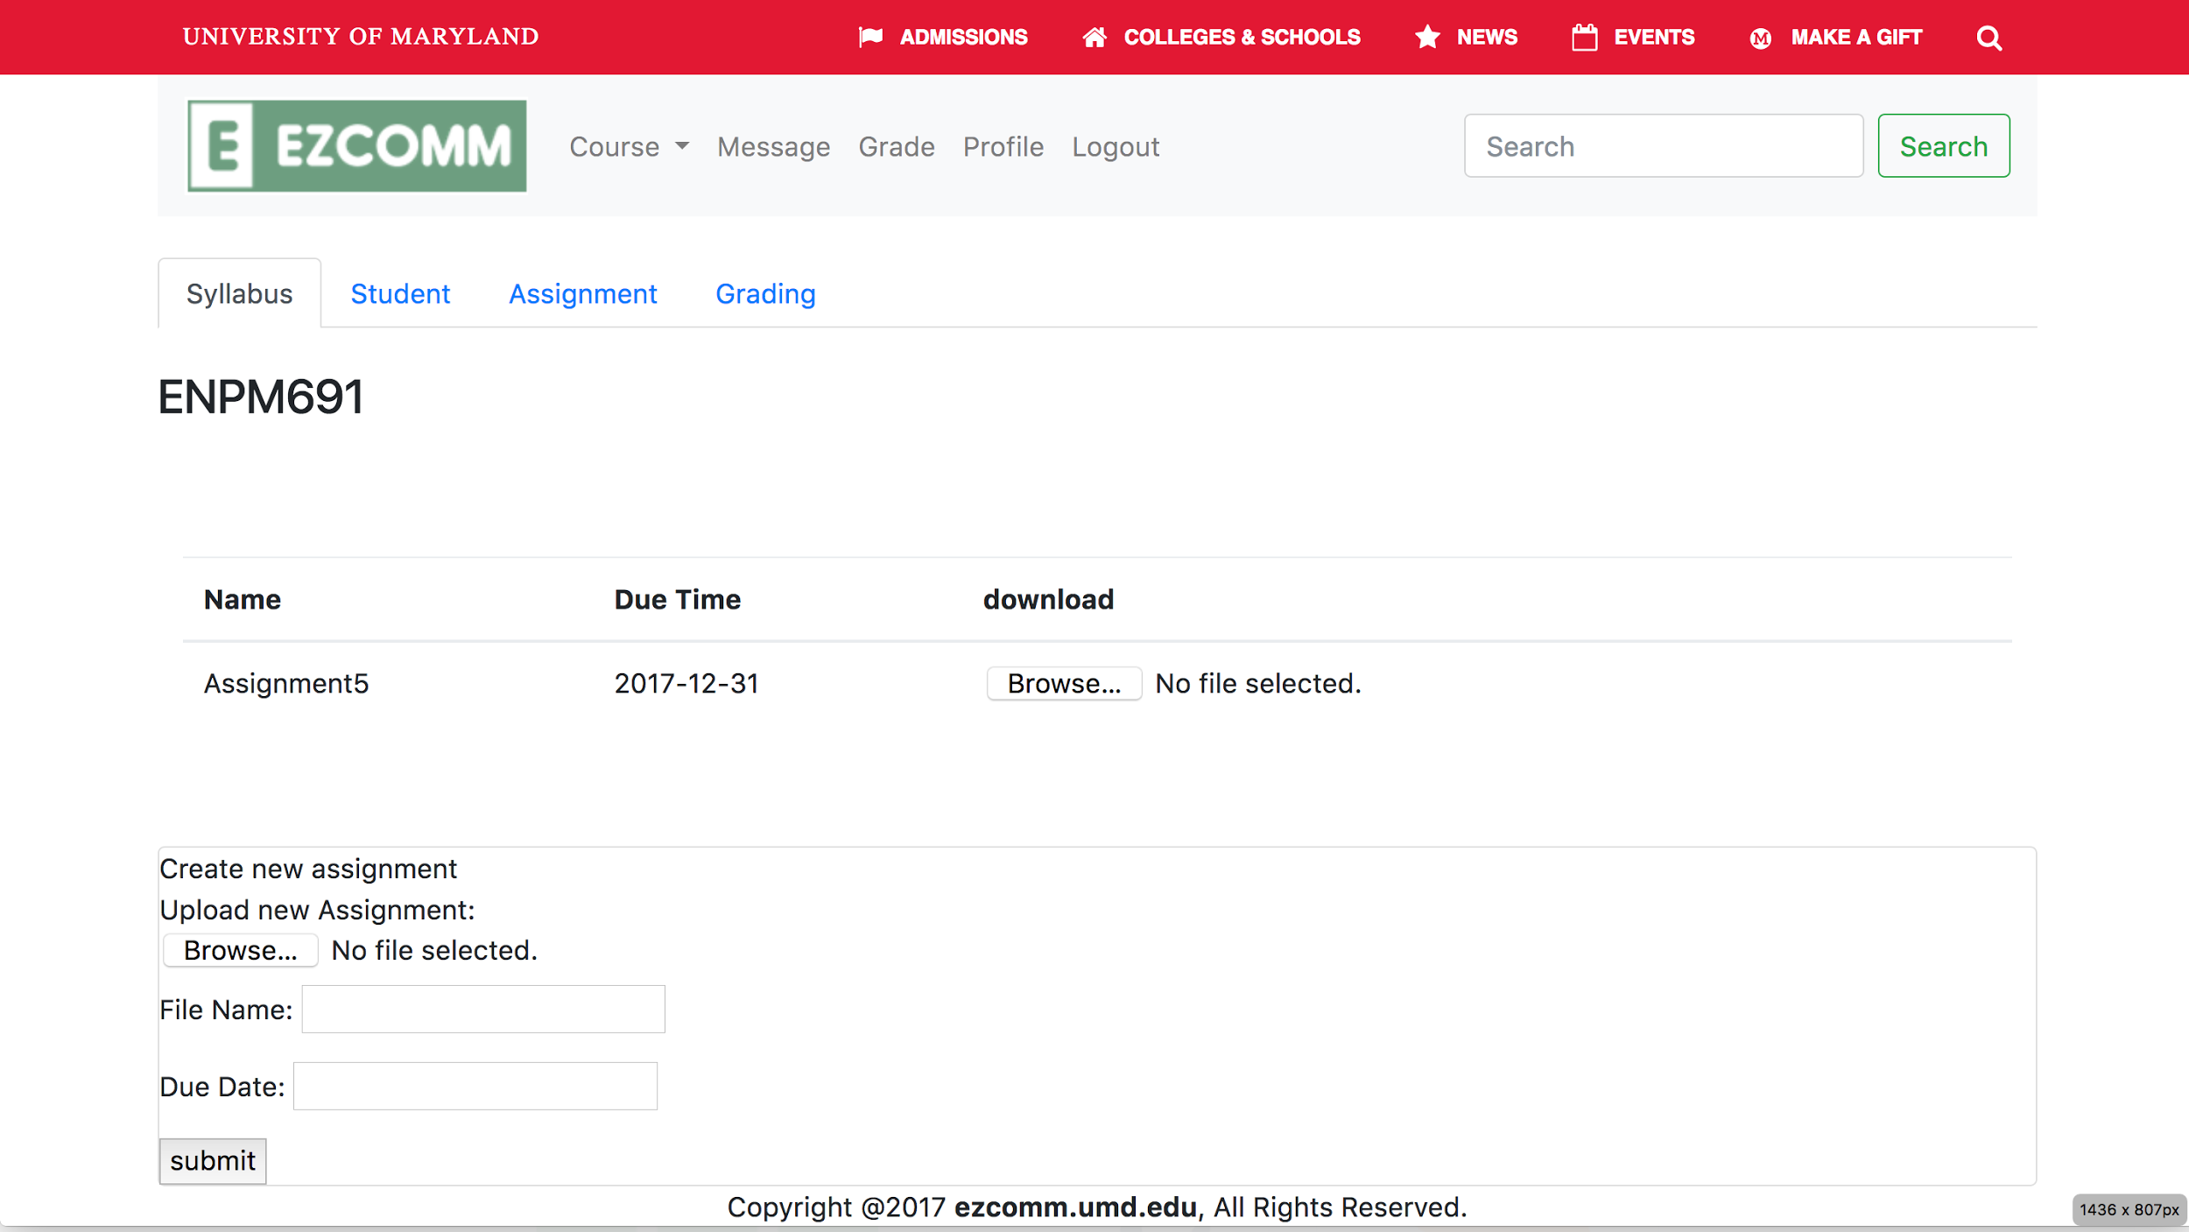

instructor can edit the current assignment :

clicking the “assignment” tab under the course >> enter the following page.

Edit Assignment: Entering the information in the input field >>> click choose file button to choose file. User will be able to edit assignment and publish it.

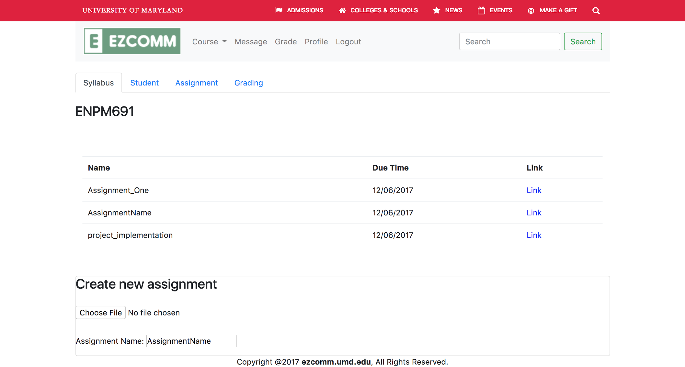

### 3.2.3 View student assignment and do grading for each student

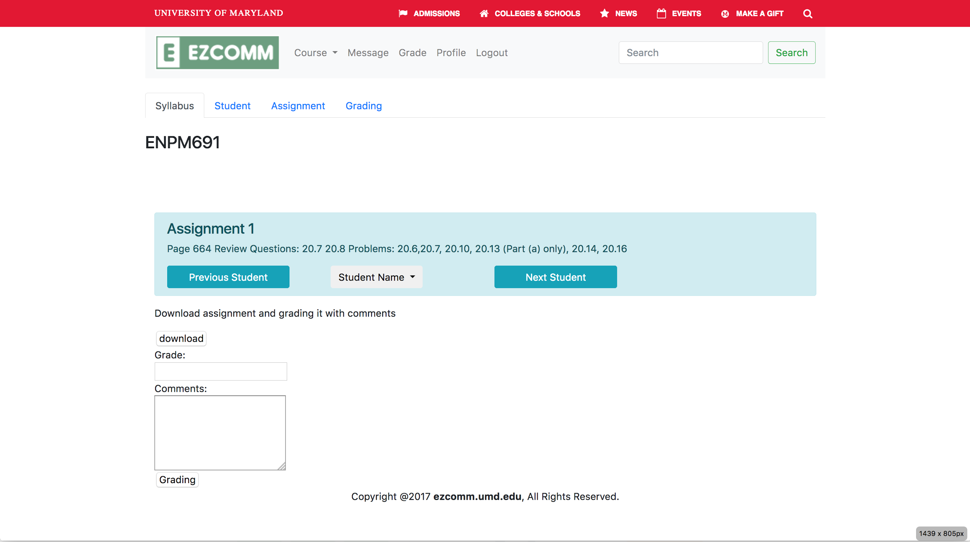

### 3.2.4 View all students who enrolled in the course he/she teach

>>Click the “Student” tab.Then all the students for the course will be presented on the screen.

>>Input the keyword inside the “search input field”. The corresponding student will be presented;

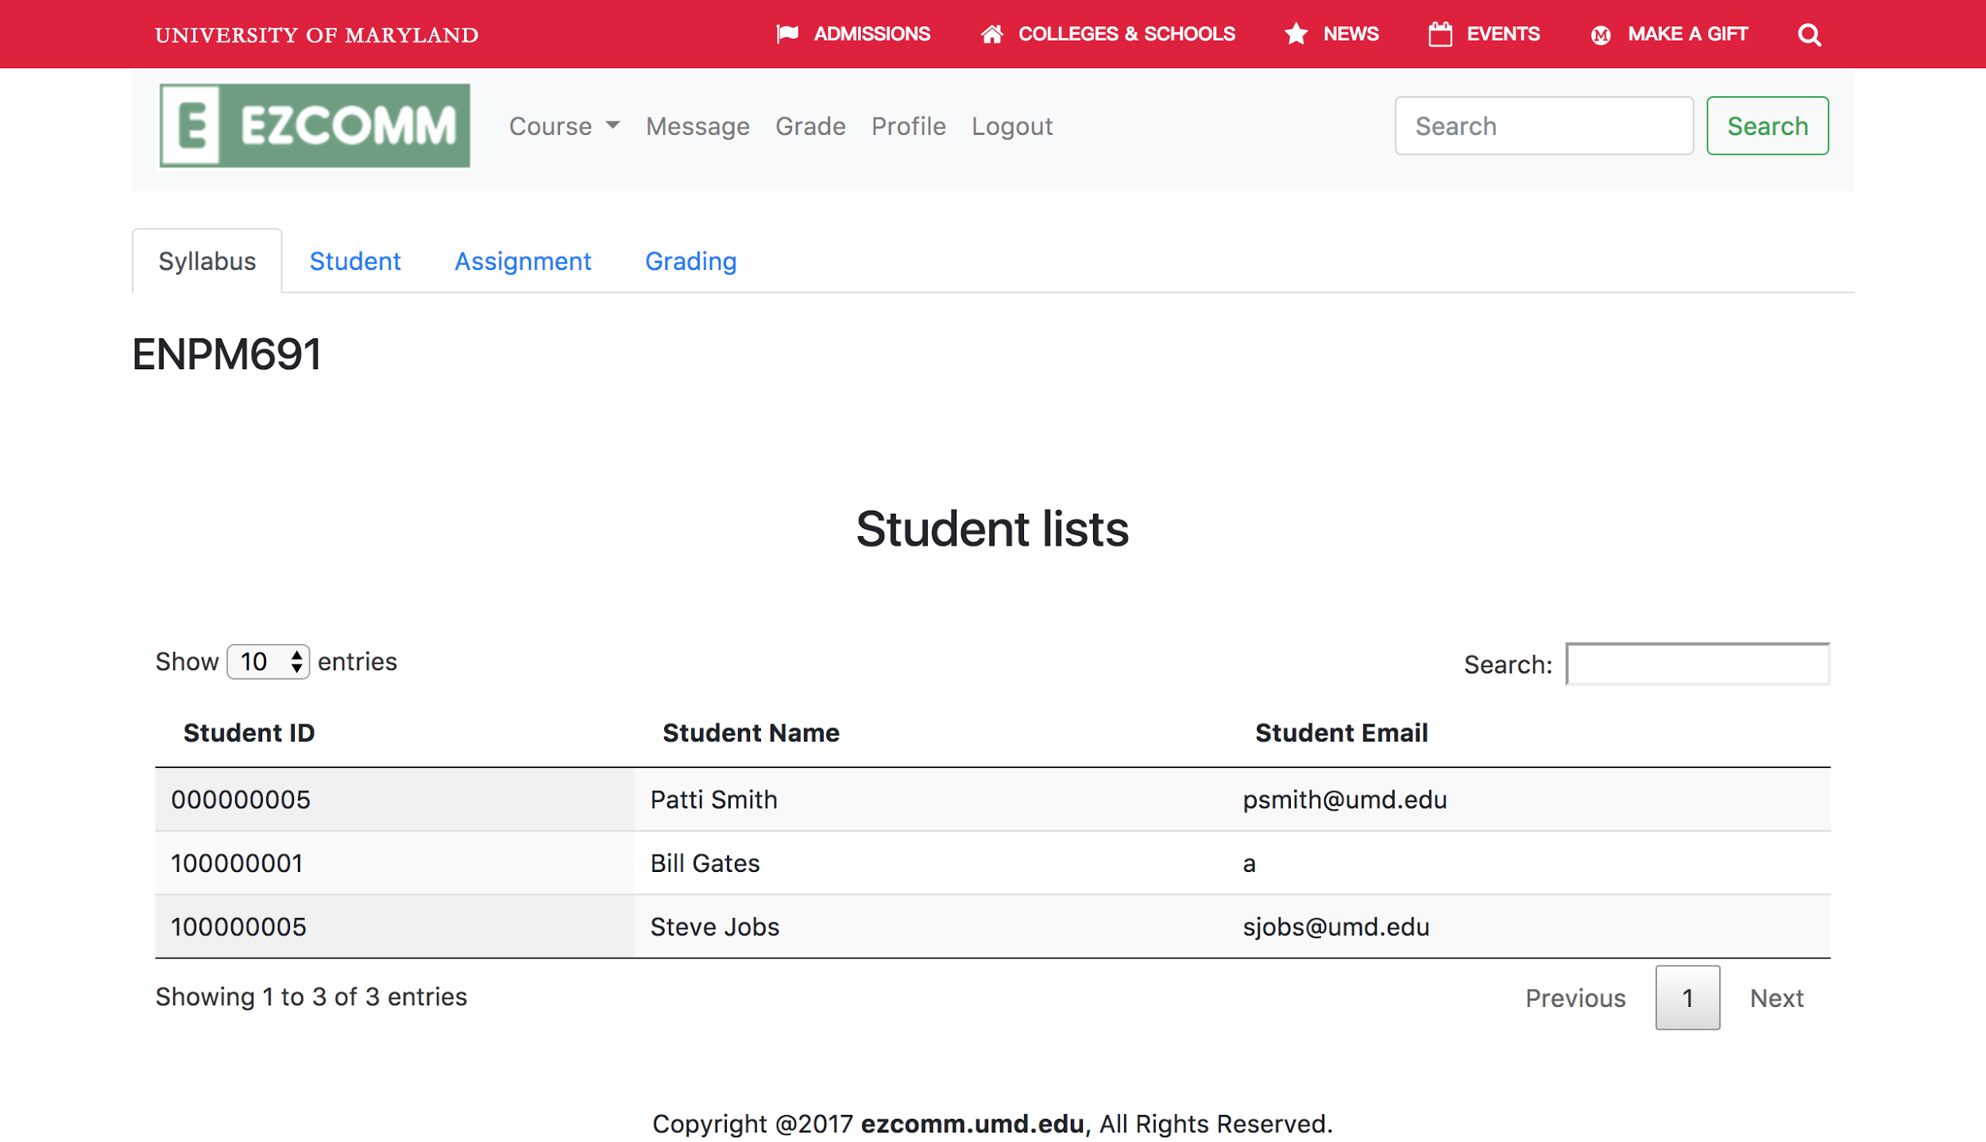

### 3.2.5 View all the gradebook for all courses in certain enrolled semester

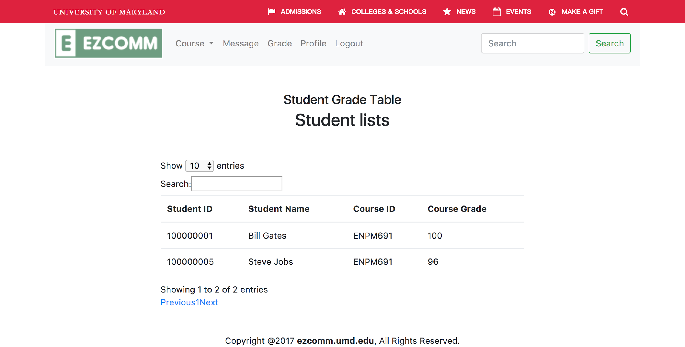

### 3.2.6 View profile and edit profile



# **4. Troubleshooting**

### 4.1 Forgot password

User can click”forget your password” on the log in page to enter the password change page.

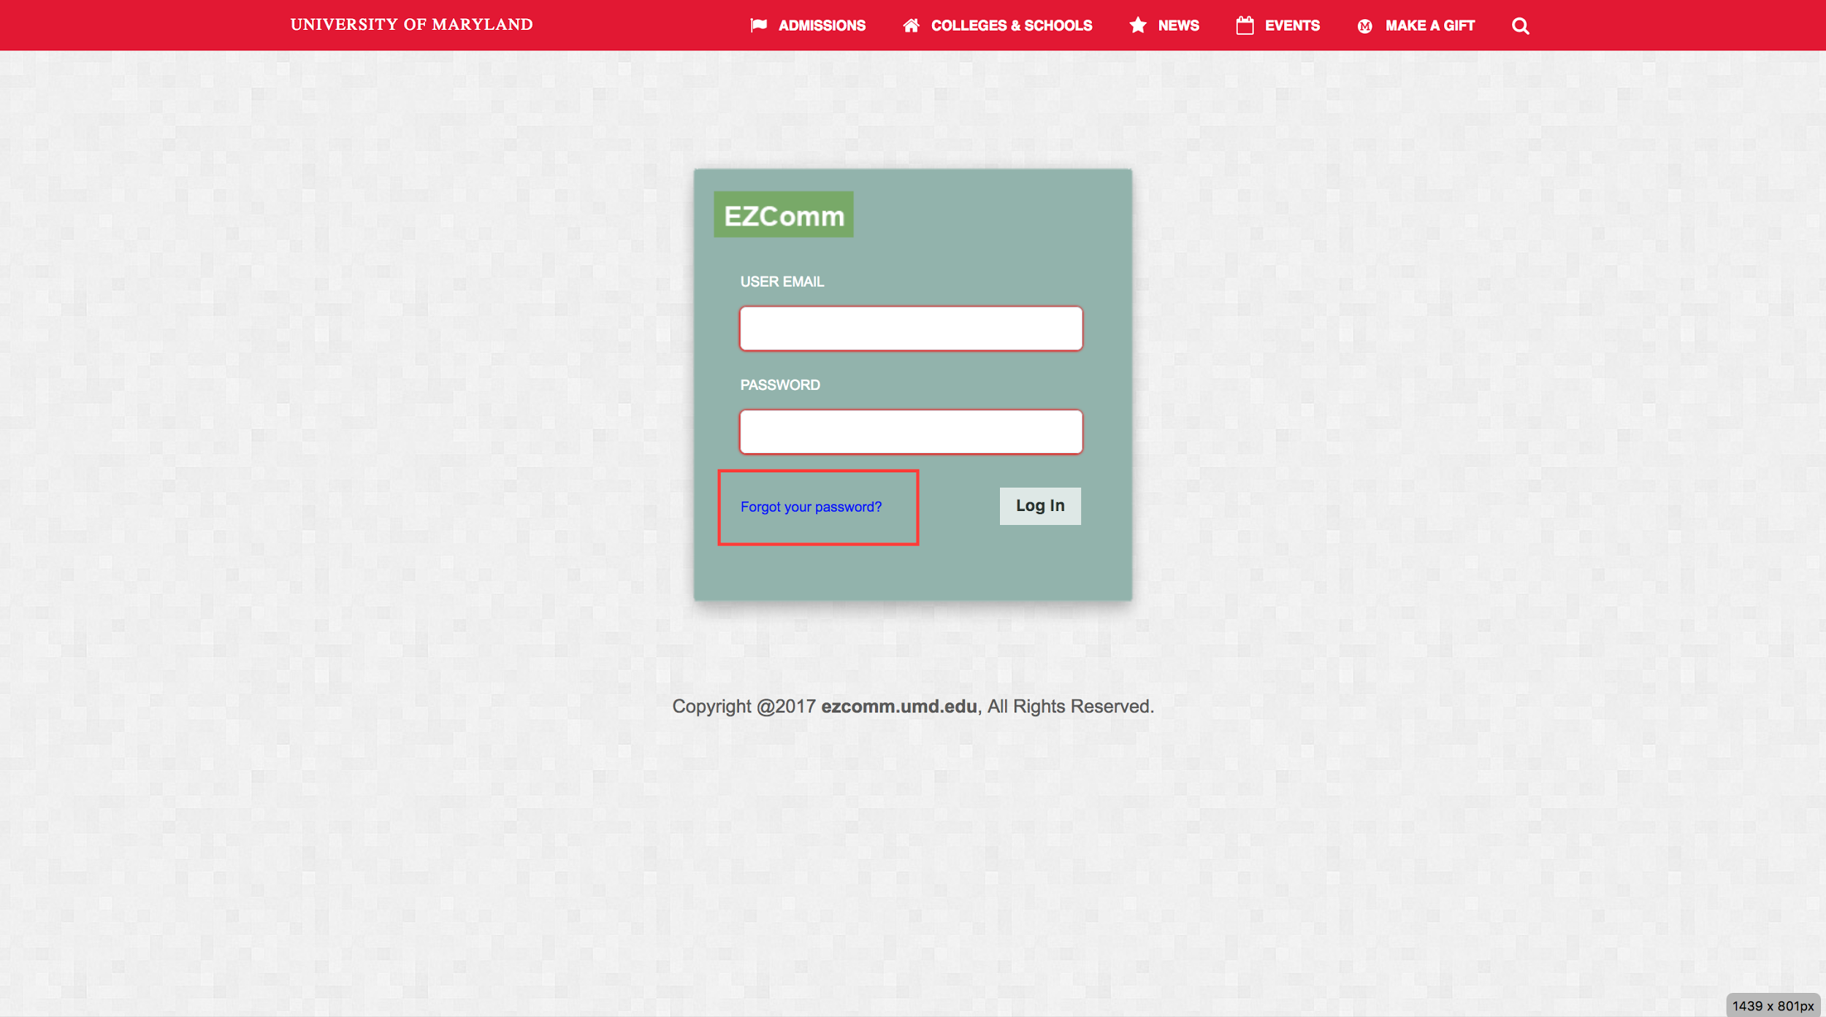

### On this page. User input his email and new password twice to confirm the new password for his account. Then click reset password will help him/her change the password;

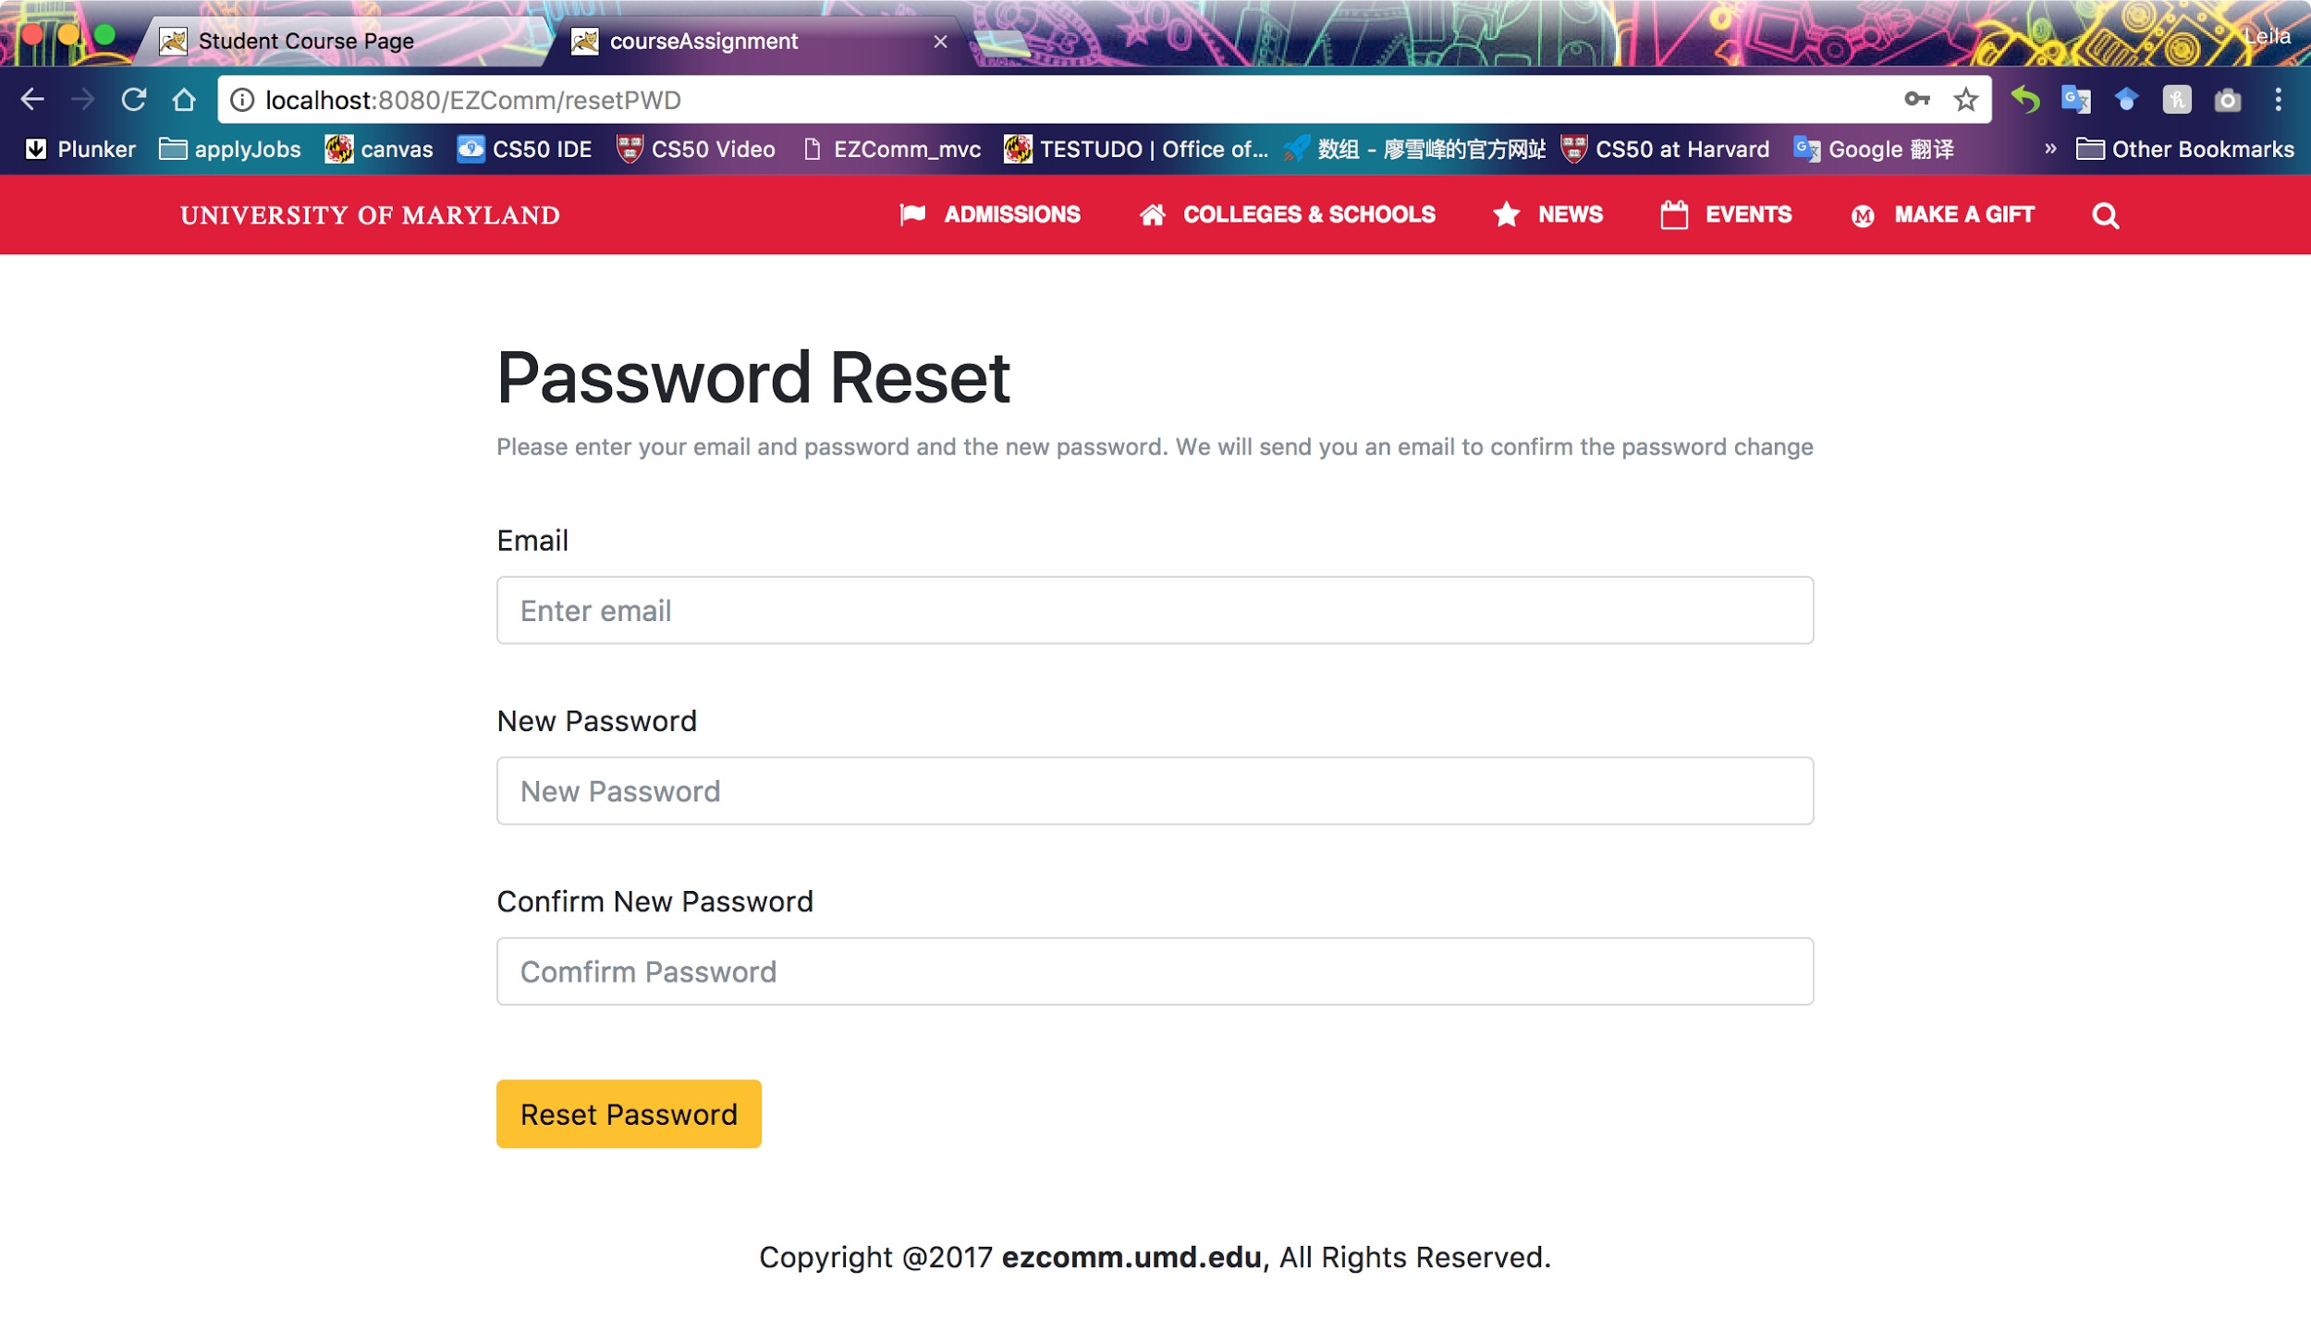

### 4.2 Incorrect password or email information

System will send an alert to inform the information that user inputs is wrong. User then can choose to re input information in this page or go to forget your password.

